**PLC Technical Report.**

# System Description

The Automated Control System is a modular system that simulates a process of PLC controlled production. Is integrated by 5 main components: A structure main, One operation panel, one control panel PLC control, a web control panel y one solenoid valve module.

It eases the following studies:

* PLC programming
* Study of Sensors
* Study of Pneumatics and Electropneumatic
* Manufacture process
* Control systems

This manual describes the general operation of the equipment, as well as the components that compose it and its general configuration. This manual is intended to be a general guide for basic operation This manual is not a substitute for the operation manuals for each individual component. The manual has been developed for trained and competent persons, such as engineers, technicians, and programmers.

# Main System Components

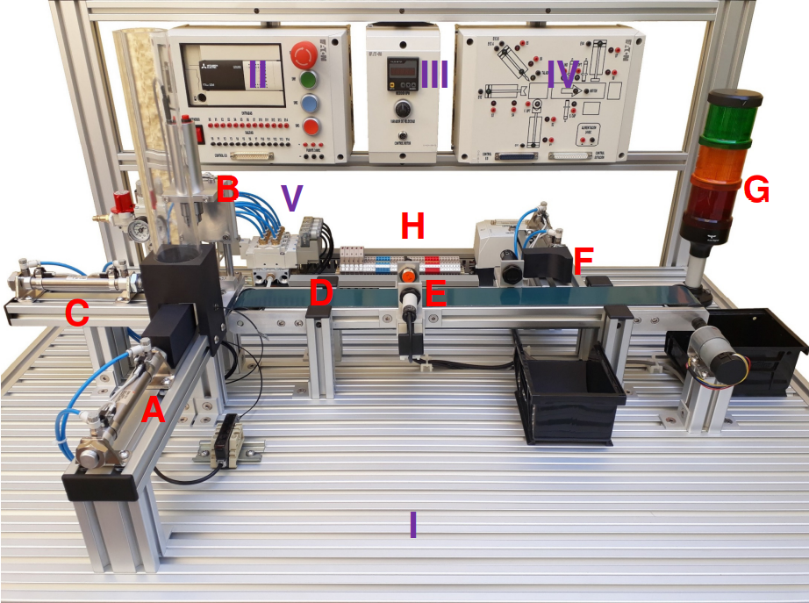

# PRINCIPAL STRUCTURE

## Material Power Unit

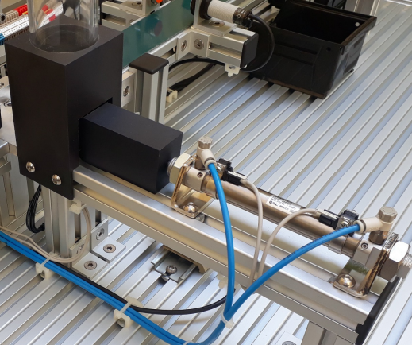Type material feeding unit vertical by gravity for workpieces round 40mm in diameter and 40mm in height and storage capacity of 8 parts.

* A double-acting cylinder with a diameter of 16mm and 75mm stroke with two flow regulators to control the drive speed
* Two reed sensors to detect the cylinder position with led indicator
* A fiber optic sensor for detection presence of material

## Manufacturing Unit

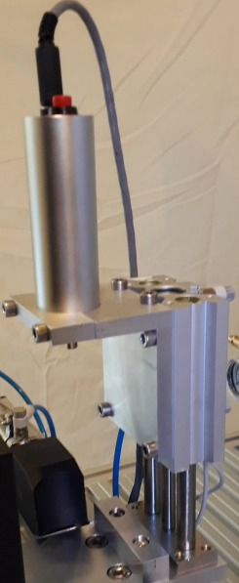

Manufacturing unit through a vertical drill simulation.

* This holds an electric drill of 24 VDC, 15000 rpm, and 30 watts.
* It is a double acting cylinder with double guide, 16mm of diameter, and 2 reed sensors for the position detection with a LED indicator.
* 50mm stroke with two flow regulators to control the drive speed

MGQM16-50 Model

The MGQ series is an air cylinder with guide integrated and two types of guide rod bearing, which can detect the cylinder’s position with built-in magnets for auto switching. It is suitable as stoppers or lifters in conveyors line, depending on which direction you install it. On the table there are some specifications to consider for its use.

This holds an electric drill of 24 VDC, 15000 rpm, and 30 watts. It is a double acting cylinder with double guide, 16mm of diameter, and 2 reed sensors for the position detection with a LED indicator.

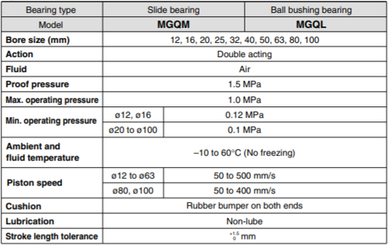

Similar to the previous model, the MGQ operates with compressed air, with a maximum operating pressure of 1.0 MPa and a minimum operating pressure of 0.12 MPa (at ø12 – ø16) or 0.1 MPa (at ø20 – ø100). It has a piston speed range from 50 to 500 mm/s (at ø12 – ø63) and from 50 to 400 mm/s (ø80 – ø100). As cushion, it has a rubber bumper on both ends to prevent damage, and a proof pressure of 1.5 MPa, with an ideal ambient and fluid temperature between -10 to 60°C.

## Loading and transfer unit

Parts loading and transfer unit working towards the conveyor belt. It consists of:

* A double-acting cylinder with a diameter of 16mm and 80mm stroke with two flow regulators to control the drive speed
* Two reed sensors to detect the cylinder position with led indicator

CD85N16-75C-B Model

From the C85 series, it is a double acting single rod, this model has several characteristics that implies a good quality and extended life service, conforming to ISO 6432 and CETOP RP52P.

* It is a high-speed actuation with a low friction and elastomer cushions seals, which enables the pistons speed up to 1500 mm/s.
* All parts are corrosion resistant. End covers and clevis are specially anodized while barrel is stainless steel. Piston rod is stainless steel up to ø16.
* It is designed to function in extremely dusty environments.
* Leak proof assembly, with double swaging of the end covers of the barrel provides an airtight union.
* Simple space-saving design with high dimensional accuracy makes these cylinders very easy to use.
* Rod seal can be quickly replaced, greatly extending the cylinder life.

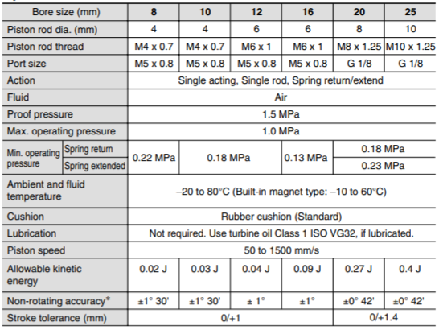As it was mentioned earlier, the fluid to enable the return or extend movement of the actuators is air, therefore, their measurement unit is in pascals (Pa). As we can see in the table, there is a range of operating pressure on which we can use the cylinders. On the maximum value, we can operate with 1.0 MPa, while on the other hand, the minimum pressure depending on the piston rod diameter, is from 0.22 MPa to 0.18 MPa if it is a spring return, and from 0.22 MPa to 0.23 MPa if it is a spring extended. On the piston speed, we also have a range from 50 to 1500 mm/s, where this is dependent to the operating pressure; with a higher pressure, a higher piston speed. As cushion, it has a standard rubber cushion, and a proof pressure of 1.5 MPa, with an ideal temperature range of -20 to 80°C.

## Conveyor Belt

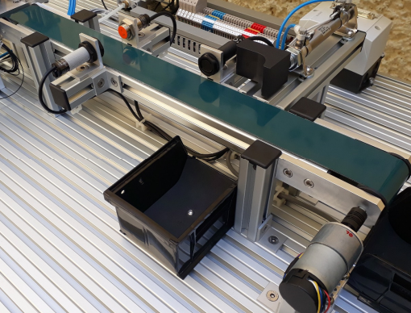A conveyor belt unit for the transportation of the product pieces through the process. Its dimensions are approximately 600 x 60 x 50 mm with a variable speed.

* Double layer green vulcanized endless belt.
* Drive by DC geared motor 12V and 70: 1,150 gear ratio RPM, Torque 14 kg-cm.
* 64-pulse quadrature encoder per revolution

## Inspection Unit

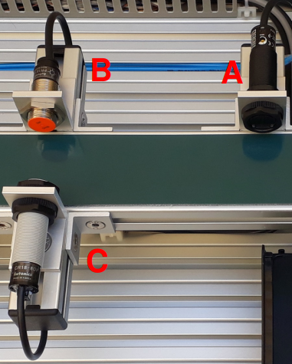Inspection unit to determine the type of workpiece material. It consists of:

1. A diffuse cylindrical type optical sensor of 18mm diameter, feed 12 to 24 VDC, sensing distance 400mm, PNP
2. One 18mm Cylindrical Type Inductive Sensor diameter, supply 12 to 24 VDC, sensing distance 5mm, PNP
3. A cylindrical type capacitive sensor of 18mm diameter, feed 12 to 24 VDC, sensing distance 8mm, PNP

## Expulsion Unit

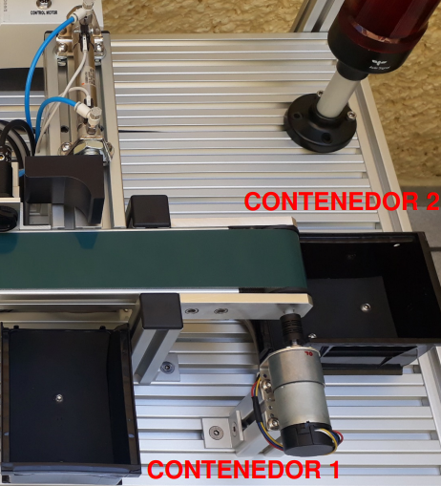Ejector unit for removing parts from work processed to the container finished pieces

* A double-acting cylinder with a diameter of 16mm and 75mm stroke with two flow regulators to control the drive speed
* Two reed sensors to detect the cylinder position with led indicator
* Container 1 of finished pieces of measures 136 x 104 x 76 mm
* Container 2 of finished pieces of measures 136 x 104 x 76 mm

## Signaling Turret

|  |  |
| --- | --- |
| PLC Output | Device Connected |
| X13 | Red light |
| X14 | Orange light |
| X15 | Green light |

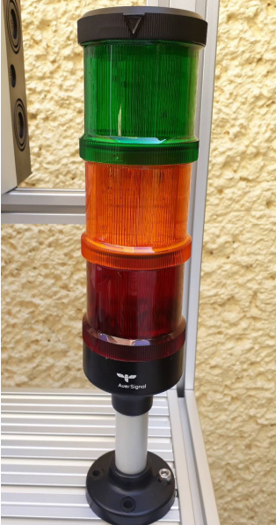Fixed light signaling tower in 3 colors: green, orange and red. 24VDC power supply. The terminals are pre-wired to the outputs of the PLC using the "Control I / O" cable and connector of the PLC Control Panel and the Control Panel Operation and is only operable when connect the system using flat cables 37-pin

## Connection Unit

Connection unit that concentrates the sensor terminals, solenoid valves, signaling turret and belt motor conveyor to connect to the Control Panel Flat cable and connector operation 37 pins [STATION CONTROL] and to the Band control by round connector and 6-pin cable [MOTOR CONTROL]

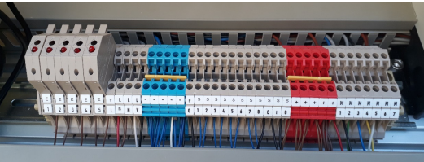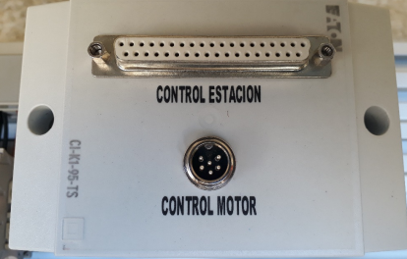

# PLC CONTROL PANNEL

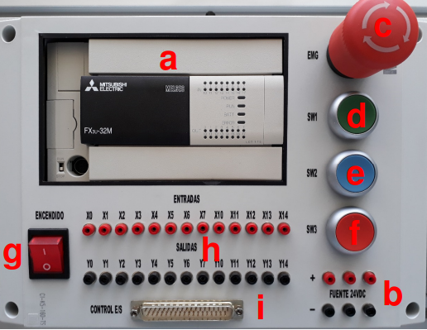Panel mounted on the frame of the structure main containing the Logic Controller FX brand programmable (PLC) family Mitsubishi. All inputs and outputs of the PLC are available with 2mm terminals for individual operation of components and additionally they are available in a connector and flat 37-pin cable for direct connection to the Operation Panel.

It consists of:

1. One 16-input FX3U-32MR / DS PLC 24VDC digital and 16 relay outputs
2. A 24VDC 2A power supply
3. An emergency stop button [EMG]
4. A green push button NO pre-wired to the digital input X15 of the PLC [SW1]
5. A blue push button NO pre-wired to the PLC digital input X16 [SW2]
6. A red NC pushbutton prewired to the PLC digital input X17 [SW3]
7. A power switch with light indicator
8. 2mm terminals for inputs and outputs i. 37-pin [I / O CONTROL] connector

FX3U-32MR/DS

Mitsubishi PLC with 16 configurable direct current digital inputs SINK (NPN) or SOURCE (PNP), 16 8A relay outputs. DIN rail mount type, Program capacity: 64,000 steps, Programming language: Ladder, List of instructions and SF. 24VDC power supply. Interchangeable communication expansion cards that install directly into the unit principal. Integrated real time clock. Basic instructions: 0.065 µs / instruction (instruction of Contact). Applied instructions: 0.642 µs / instruction (MOV instruction)

1. 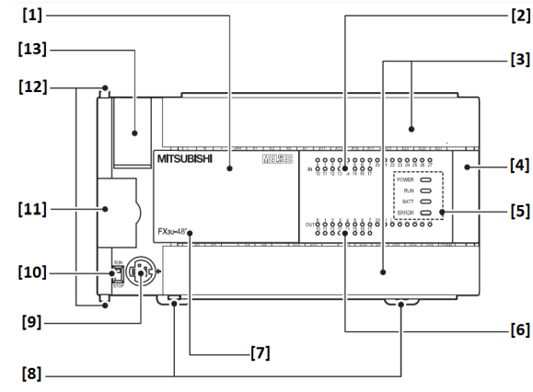Cover
2. Status indication of the inputs
3. Connection terminal cover
4. Extension connection cover
5. LED indication
6. Status indication of the outputs
7. Base unit type
8. Mounting tab for DIN rail
9. Programming units interface
10. RUN / STOP switch
11. Adapter slot cover
12. Interlock for adapter module
13. Battery compartment cover
14. 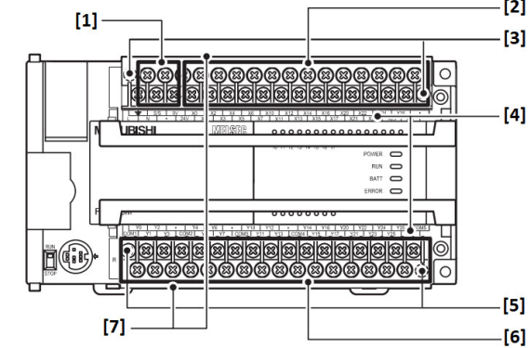Connections for supply voltage
15. Input connections
16. Fastening screws for the terminal block higher
17. Designation of the connections
18. Fastening screws for the terminal block lower
19. Output connections
20. Contact protection

Input and output configuration

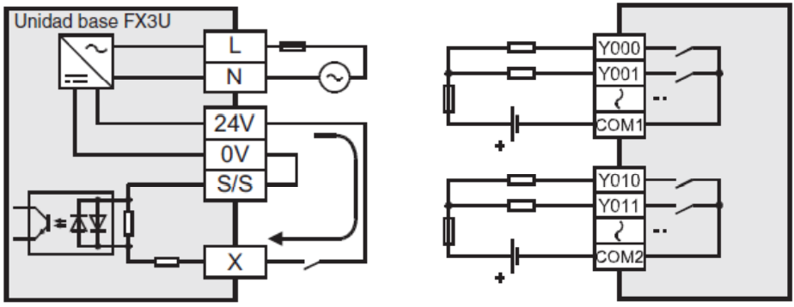

Input assignment table for the 37-pin [I / O CONTROL] connector

|  |  |
| --- | --- |
| PLC Inputs | Device Connected |
| X0 | Optical fiber sensor [F. OPT] |
| X1 | Feed Unit Piston Reed Sensor “Retracted” [S1] |
| X2 | Feed Unit Piston Reed Sensor “Extended” [S2] |
| X3 | Reed Sensor Charge and Transfer Unit Piston "Retracted" [S3] |
| X4 | Reed Sensor Charge and Transfer Unit Piston "Extended" [S4] |
| X5 | Reed Sensor Manufacturing Unit Piston "Retracted" [S5] |
| X6 | "Extended" Manufacturing Unit Piston reed sensor [S6] |
| X7 | Reed Sensor Eject Unit Piston "Retracted" [S7] |
| X10 | Ejection Unit Piston reed sensor “Extended” [S8] |
| X11 | Capacitive Sensor [S. CHAP] |
| X12 | Inductive sensor [S. IND] |
| X13 | Optical Sensor [S. OPT] |
| X14 | Not assigned |
| X15 | Green Button NA [SW1] |
| X16 | Blue Button NA [SW2] |
| X17 | Red NC button [SW3] |

Output assignment table for the 37-pin [I / O CONTROL] connector

|  |  |
| --- | --- |
| PLC Outputs | Device Connected |
| Y0 | Power Unit Solenoid Valve [EV1] |
| Y1 | Charge and Transfer Unit Solenoid Valve [EV2] |
| Y2 | Manufacturing Unit Solenoid Valve Position A [EV3 A] |
| Y3 | Manufacturing Unit Solenoid Valve Position B [EV3 B] |
| Y4 | Ejection Unit Solenoid Valve [EV4] |
| Y5 | Drill |
| Y6 | Conveyor Belt |
| Y7 | Not assigned |
| Y10 | Not assigned |
| Y11 | Not assigned |
| Y12 | Not assigned |
| Y13 | Not assigned |
| Y14 | Not assigned |
| Y15 | Red Signal Turret Lamp |
| Y16 | Orange Signal Turret Lamp |
| Y17 | Green Signal Turret Lamp |

Main Operating Monitors

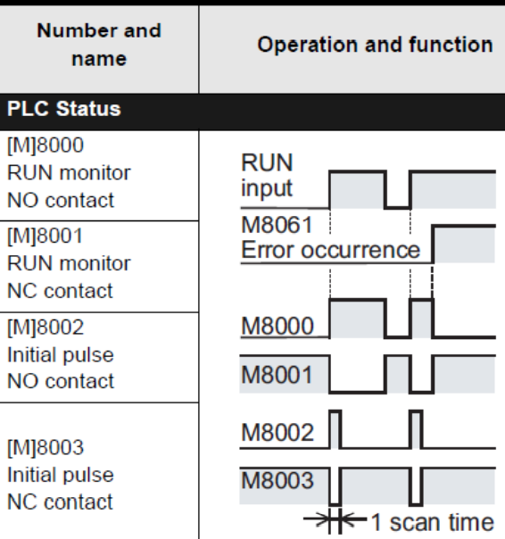

# BELT CONTROL PANEL

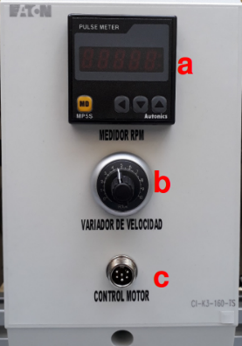

Panel mounted on the frame of the structure main containing speed control of the conveyor belt motor, with a integrated 12VDC source.

1. An engine rev meter
2. One controller and speed knob band motor
3. One 6-pin [CONTROL MOTOR] for connection to the connection in the main structure

# OPERATION PANEL

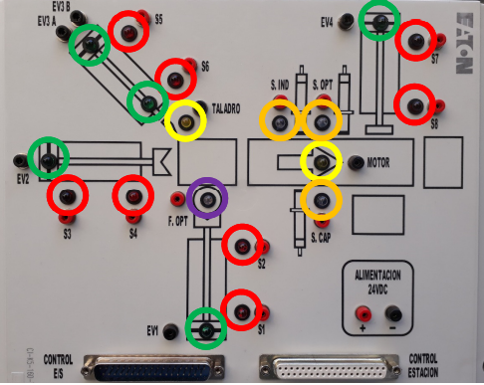Panel mounted on the frame of the structure main with led indicators to display the status of the components from the main structure through the connector and 37-pin flat cable. Inputs and outputs of the components of the main structure They are available in 2mm terminals for individual operation of components and additionally allows wireless programming practices using the flat cable and connector 37-pin to establish communication between the operation panel and the control panel from the PLC.

It consists of:

1. 8 LED indicators in red color of the reed sensors of each cylinder of the system [S1… S8]
2. 2 Yellow LED indicators for the belt motor operating status conveyor and drill [MOTOR, DRILL]
3. 3 Orange LED indicators for the sensors of the inspection unit [S. CAP, S. IND, S. OPT]
4. 5 LED indicators in green color for the operating status of the solenoid valves [EV1, EV2, EV3 A, EV3 B, EV4]
5. 1 LED indicator in violet color for the fiber optic sensor
6. 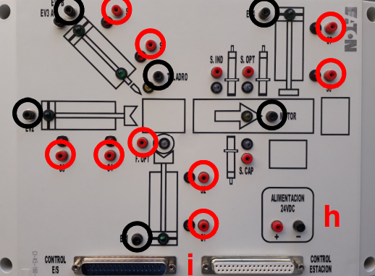2mm **black** terminals for the signals from the Solenoid Valves, Motor and Drill coming from the structure principal
7. 2mm red terminals for the sensor signals from the Principal structure
8. Terminals for power supply input 24VDC when the power cord is not used CONTROL I / O connector
9. 2 37-pin connectors for connection Directly with the PLC Control Panel [I / O CONTROL] and Main Structure [STATION CONTROL]

# ELECTRO VALVE MODULE

Direct mounted on the table of the main structure that connections are wired to Unit of connection.

1. 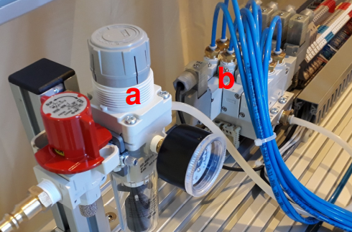A maintenance unit (Filter + Regulator) and shut-off valve
2. A block of 4 electro valves positions with a bistable solenoid valve and three single solenoid valves with quick connectors for 4mm hose diameter and 24VDC coils with led indicator of operation and a maximum operating pressure of 10 Pub.

# System Power Up Procedure

1. Review and follow the safety recommendations in section 1 of this manual
2. Connect the equipment to the electrical supply
3. Connect the 6-pin cable to the MOTOR CONTROL ports on the Engine Control Panel. Band and Main Structure Connection Unit
4. Connect the 37-pin male-male flat cable to the STATION CONTROL ports of the Operation Panel and Main Structure Connection Unit

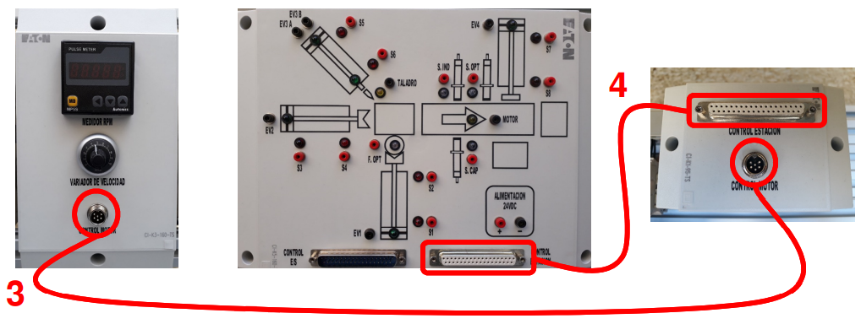

1. 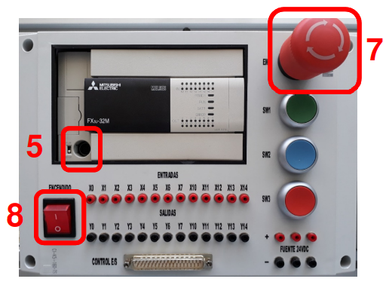Connect the programming cable to the PLC port and PC if downloading any program to PLC
2. Make the desired connections between the PLC Control Panel and the Control Panel. Operation
3. Disable the emergency stop in the PLC Control Panel
4. Turn on the main switch of the PLC Control Panel. The switch indicator light

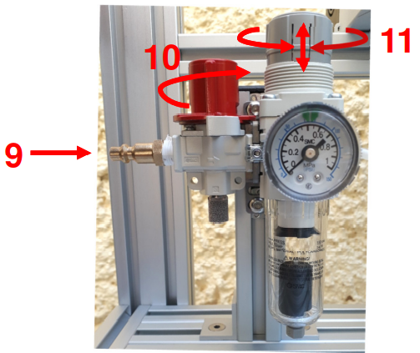

1. Connect the air line to the maintenance unit
2. Close the shut-off valve
3. Adjust the air pressure to the green indicator mark on the pressure gauge. Lift the knob to unlock the regulator and turn the regulator to increase or decrease the pressure of job. Lower the knob to re-lock the regulator when you have adjusted the pressure

# Configurations of Point to Point Connections

* To connect the sensors of the Operation Panel, connect each of the terminals colored red [S1… S8, F. OPT, S. CAP, S. IND, S. OPT] exclusively to the red terminals of the inputs of the PLC Control Panel [X0… X14]
* For the connection of the actuators of the Operation Panel, connect each of the black terminals [EV1, EV2, EV3 A, EV3 B, EV4, MOTOR, DRILL] exclusively to the black terminals of the PLC Control Panel outputs [Y0… Y14]

**REMEMBER TO TURN OFF THE MAIN SWITCH EVERY TIME YOU PERFORM OR MODIFY SOME CONNECTIONS**

**WARNING**

**DO NOT DIRECTLY CONNECT THE 24VDC POWER OUTPUT TO THE RED TERMINALS OF THE SENSORS ON THE OPERATION PANEL AS IT COULD PERMANENTLY DAMAGE THE LED INDICATORS AS WELL AS THE SENSORS**

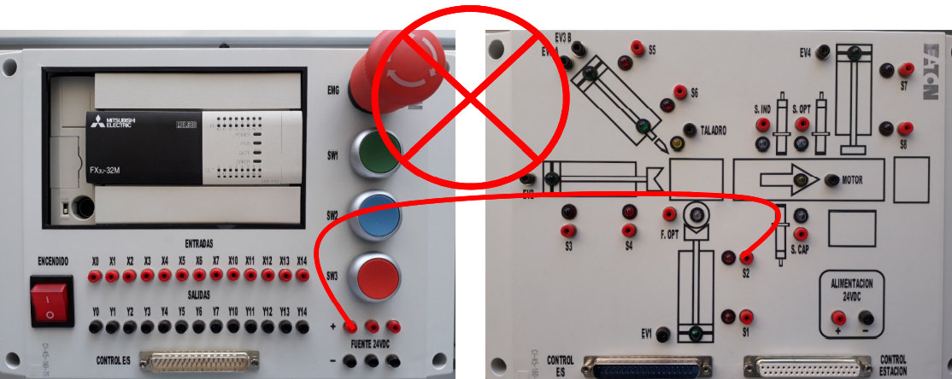

**WARNING**

**DO NOT CONNECT THE PLC OUTPUTS TO THE RED TERMINALS OF THE SENSORS IN THE OPERATION PANEL AS IT COULD DAMAGE THE LED INDICATORS AS WELL AS THE SENSORS**

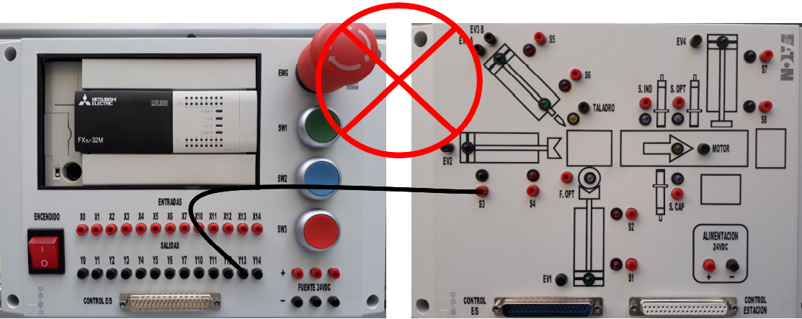

Connection example of the Material Feeding Unit

|  |  |
| --- | --- |
| INPUTS > SENSORS | OUTPUTS > ACTUATORS |
| X0 > F. OPT | Y0 > EV1 |
| X1 > S1 |  |
| X2 > S2 |  |

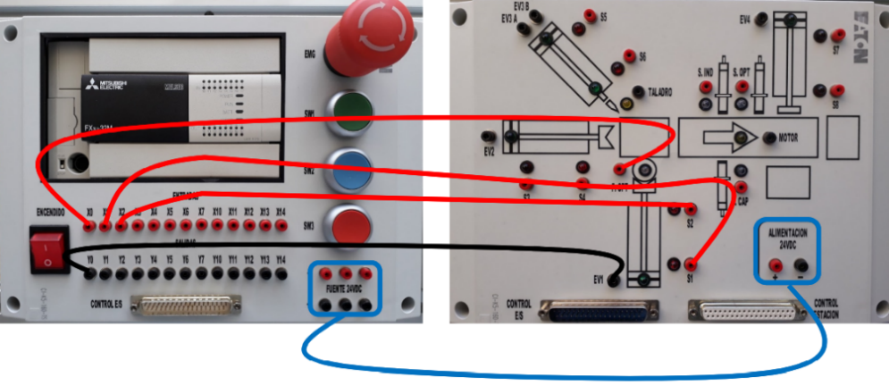

Connection example of the Loading and Transfer Unit

|  |  |
| --- | --- |
| INPUTS > SENSORS | OUTPUTS > ACTUATORS |
| X3 > S3 | Y1 > EV2 |
| X4 > S4 |  |

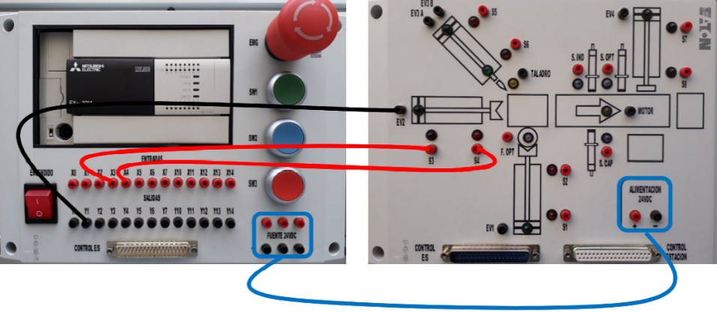

Manufacturing Unit connection example

|  |  |
| --- | --- |
| INPUTS > SENSORS | OUTPUTS > ACTUATORS |
| X5 > S5 | Y2 > EV3 A |
| X6 > S6 | Y3 > EV3 B |
|  | Y5 > DRILL |

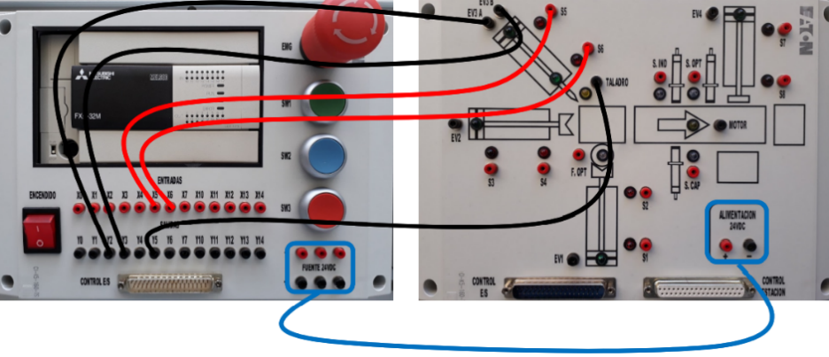

Conveyor Belt Unit Connection Example

|  |  |
| --- | --- |
| INPUTS > SENSORS | OUTPUTS > ACTUATORS |
|  | Y6 > MOTOR |

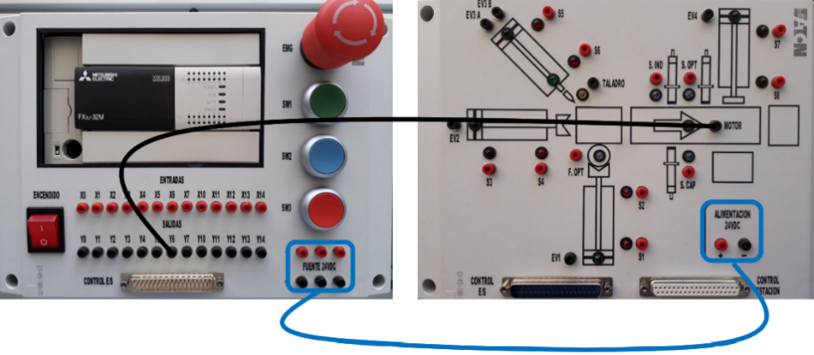

Inspection Unit Connection Example

|  |  |
| --- | --- |
| INPUTS > SENSORS | OUTPUTS > ACTUATORS |
| X11 > S. CAP |  |
| X12 > S. IND |  |
| X13 > S. OPT |  |

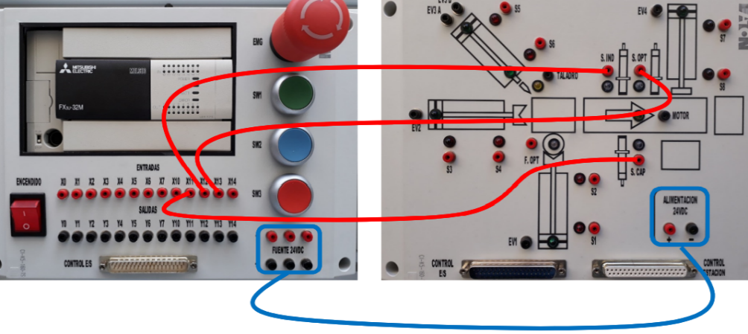

Example of Connection of the Ejection Unit

|  |  |
| --- | --- |
| INPUTS > SENSORS | OUTPUTS > ACTUATORS |
| X7 > S7 | Y4 > EV4 |
| X10 > S8 |  |

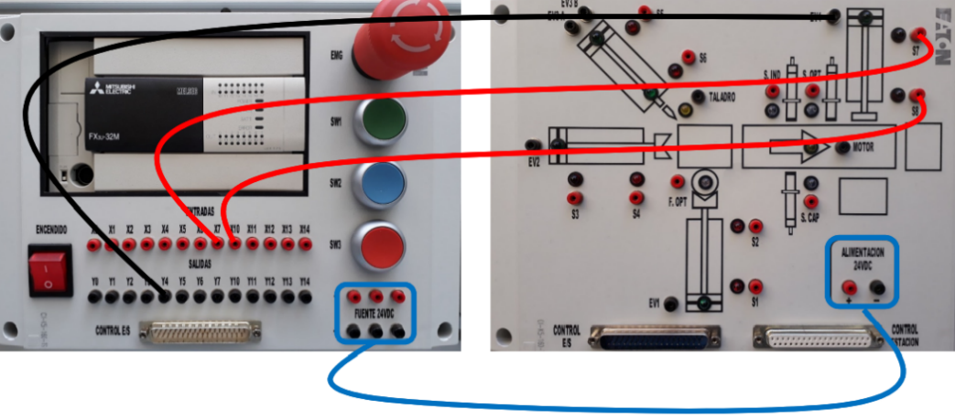

# CONNECTION CONFIGURATION THROUGH I / O CONTROL CONNECTOR

As an alternative to point-to-point connection of inputs and outputs via cables banana, you can use the 37-pin female-male flat cable and connector [I / O CONTROL] for direct communication between the PLC Control Panel and the Operation Panel with the already established configuration of input and output addresses. With this it is no longer necessary connect any banana cables for system operation.

**IMPORTANT:**

**DO NOT CONNECT THE I / O CONTROL CONNECTOR AND THE POINT-TO-POINT CONNECTION WITH BANANA CABLES TO AVOID DUPLICATION OF SIGNALS AND POSSIBLE SYSTEM MALFUNCTION**

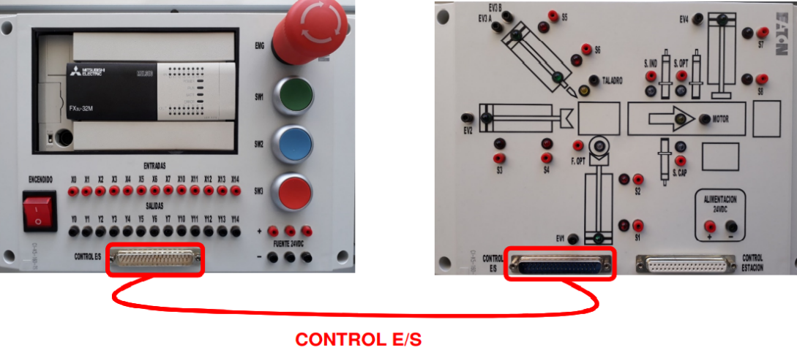

# I / O CONTROL CONNECTOR INPUT AND OUTPUT ASSIGNMENT TABLE

Input assignment table for the 37-pin [I / O CONTROL] connector

|  |  |
| --- | --- |
| PLC Inputs | Device Connected |
| X0 | Optical fiber sensor [F. OPT] |
| X1 | Feed Unit Piston Reed Sensor “Retracted” [S1] |
| X2 | Feed Unit Piston Reed Sensor “Extended” [S2] |
| X3 | Reed Sensor Charge and Transfer Unit Piston "Retracted" [S3] |
| X4 | Reed Sensor Charge and Transfer Unit Piston "Extended" [S4] |
| X5 | Reed Sensor Manufacturing Unit Piston "Retracted" [S5] |
| X6 | "Extended" Manufacturing Unit Piston reed sensor [S6] |
| X7 | Reed Sensor Eject Unit Piston "Retracted" [S7] |
| X10 | Ejection Unit Piston reed sensor “Extended” [S8] |
| X11 | Capacitive Sensor [S. CHAP] |
| X12 | Inductive sensor [S. IND] |
| X13 | Optical Sensor [S. OPT] |
| X14 | Not assigned |
| X15 | Green Button NA [SW1] |
| X16 | Blue Button NA [SW2] |
| X17 | Red NC button [SW3] |

Output assignment table for the 37-pin [I / O CONTROL] connector

|  |  |
| --- | --- |
| PLC Outputs | Device Connected |
| Y0 | Power Unit Solenoid Valve [EV1] |
| Y1 | Charge and Transfer Unit Solenoid Valve [EV2] |
| Y2 | Manufacturing Unit Solenoid Valve Position A [EV3 A] |
| Y3 | Manufacturing Unit Solenoid Valve Position B [EV3 B] |
| Y4 | Ejection Unit Solenoid Valve [EV4] |
| Y5 | Drill |
| Y6 | Conveyor Belt |
| Y7 | Not assigned |
| Y10 | Not assigned |
| Y11 | Not assigned |
| Y12 | Not assigned |
| Y13 | Not assigned |
| Y14 | Not assigned |
| Y15 | Red Signal Turret Lamp |
| Y16 | Orange Signal Turret Lamp |
| Y17 | Green Signal Turret Lamp |

# CREATING A PROGRAM

For the configuration and use of the software refer to the separate manual

* Manual GX-WORKS2_FX3U [Mitsubishi PLC Programming Software]

# SYSTEM SHUTDOWN PROCEDURE

1. Open the shut-off valve
2. Disconnect the air line from the maintenance unit
3. Turn off the main switch of the PLC Control Panel
4. Preferably enable emergency stop in the PLC Control Panel
5. Disconnect the programming cable from the PLC Control Panel.

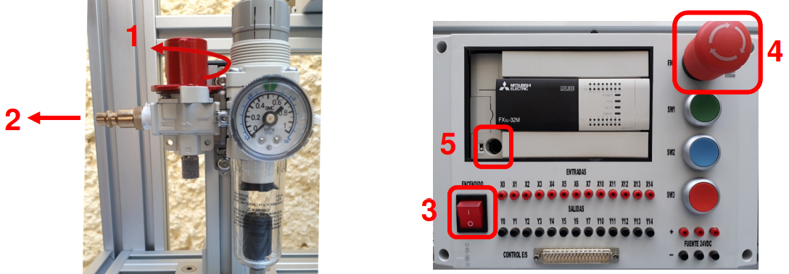

1. Disconnect the banana cables or ribbon cable between the PLC Control Panel and the Operation Panel
2. Disconnect the cables from the STATION CONTROL AND ENGINE CONTROL connectors. the Main Structure Connection Unit and the Operation and Control Panels of Band
3. Disconnect the equipment from the power supply

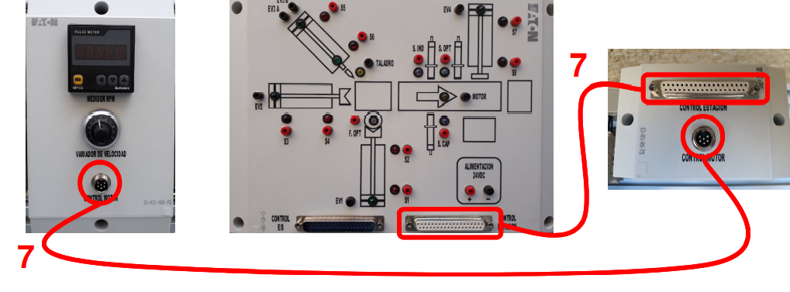

The organization scheduled a few days to get in touch with the customer, the customer presented several characteristics that determine the functionality of its machinery. One of the first footsteps is to turn on the compressor, which prepares the pneumatic valves in the workbench to position the cylinders and start working.

The organization labeled each cylinder with letters, PA to PD to distinguish between them and its components that composes the control and sensors.

The workbench consists in a set of three identical double effect cylinders, PA, PB, and PD which handles two sensors determining the limits of movement, marked as A1 for the non-active state or A2 for the active state, in the other hand the control supports a single two-way quintuple valve with a spring determining the initial state as normally open, the valve stays as non-active.

In the other hand the cylinder PC handles a different valve, it carries the same sensing attributes as the others, but it carries a three-way quintuple valve, carrying a normally sealed sate, both coils that handle its control are labelled as PC1, and PC2.

The workbench carries a set of sensors labelled as their names, SF for the Fiber Optic Sensor, SI for the Inductance Sensor, SC for the Capacitive Sensor, and SL for the Lux Sensor. It also handles a Variable Frequency Drive that supports the motor control for a band that carries the entire process, the label MT represents the coil that controls the band.

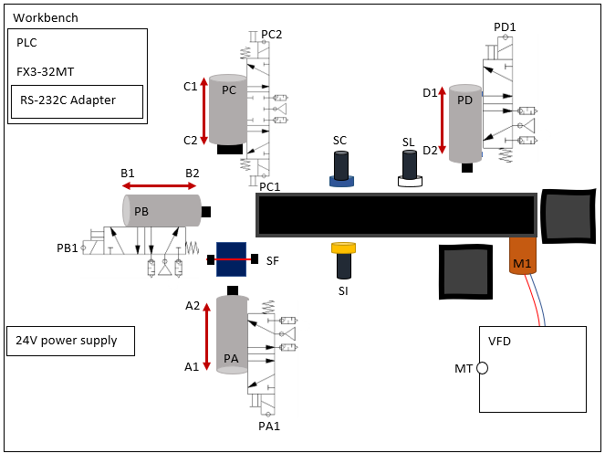

AC main voltage

The organization arranged with the customer an RS-232C adapter, which will carry a RS232 communication with microcontroller to handle data transmission over internet, which in this case, the ESP32 fits perfectly. The RS232 communication will be handled by the MAX232 chip, that transform the RS232 into 5 volts logic TTL, an UART module inside of the ESP32 will interface with it.

The process started by analyzing the process. First at all the system might remain in some predefined positions, according to the scheme of the system done by the organization.

The cylinder A, B and D must remain contracted, but C must be extended, which means that sensors A1, B1, C1 and D1 must be enabled to start the operation, then the sensor SF must be activated to verify that the system containing a piece of material to start the manufacturing process.

Once the principal configuration is done, the user could push the green button to represent the start of the system, in that way, immediately the cyl A must be extended for staying there until Cyl C terminates its purposes, while Cyl A extended, the Cyl C must be contracted to perform the drilling, to later being extended again, when the Cyl C stays at its beginning position, Cyl A must recover to its initial state and Cyl B must be extended to move the piece to the band, then, when the Cyl B gets back to its initial state, the motor which allows the movement in the band will be turned on. Then a logical operation is done with the sensors SI and SC, if the material is plastic only one of them will be triggered, but if the material is metallic, both are going to be set up. The organization though that it could be implemented an and gate to represent the combinational logic in that section, the selection must be done and stored in a memory to remember, then in the next part is divided in two different possibilities, a plastic, or a metallic material. the sensor SL will trigger the divergence, if there is a plastic material the band will remain on until the material is allocated in its place, but if it is a metallic material, the band will stay on until a second and it will stop in a certain position to being moved by the Cyl D.

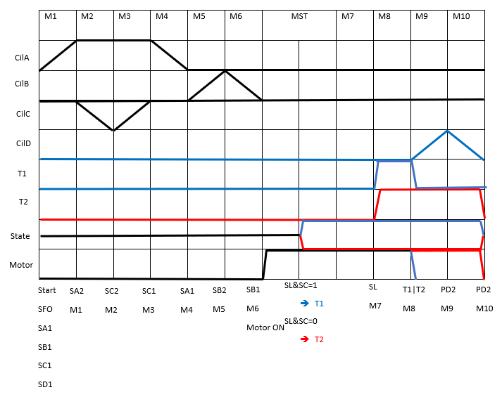

By applying the methodology, a control table was developed following the structure shown in the phase diagram.

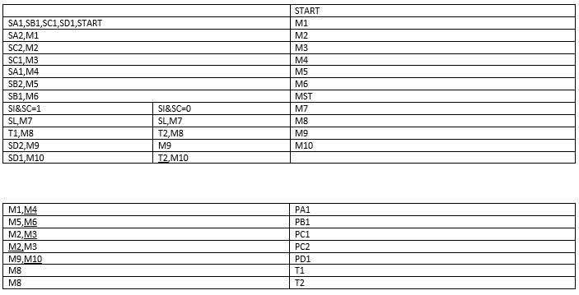

Finally, the power table was realized regarding the power appliances done in each section and memory instance.



The organization developed the ladder diagram where it was followed the instructions to operate in a simulation which determines the same functionality as the real PLC workbench. It was used fluid sim to simulate the pneumatic actuators and sensors involved in the machinery.

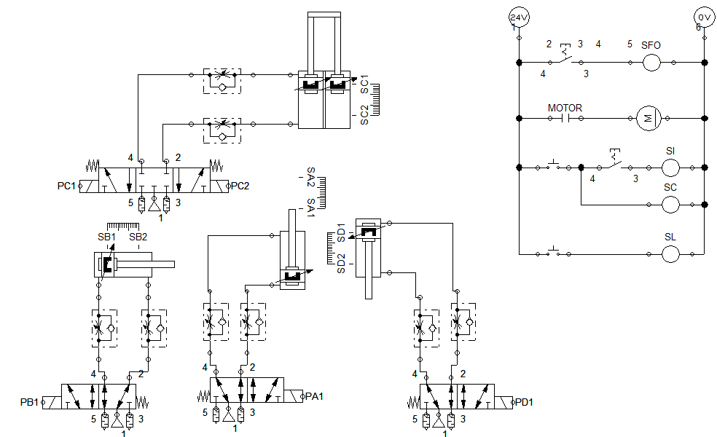

By doing that the approach may be closer to the real application in the field, the use of such development platforms eases the design and the implementation of the automation involved in the machinery without taking any risk.

The ladder diagram followed the instructions done in the power table, which served as a basis to structure the entire ladder automation to perform the required action.

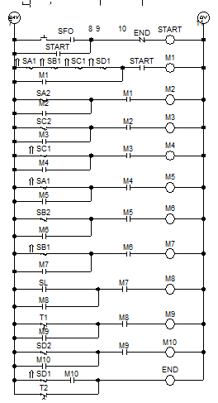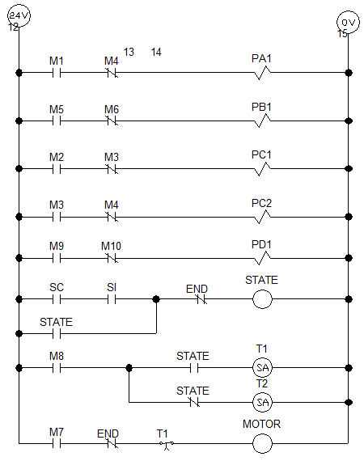

The ladder diagram designed by the organization was approved by the customer, so it was time to deploy the system to find what could be improved, the control table, power table and ladder diagram was translated to the Gxworks2 software, which corresponds to the software used to use the PLC inside of the MW.

The implementation was successful, and the customer arranged a set of parameters that could be included to enhance the process and approach the enough security at implementing it.

The customer required a drill that might turn on before the manufacturing cylinder is contracted to ensure the correct usage of the drill, nevertheless it was also shown that the motor that stablish a ON state once the machine started to work, it might turn off only if it’s required for categorizing objects or if there is a problem in the machine.

Also, it was required a module that observes the behavior of the machine, the customer indicated that the best approach might be a watchdog timer, which might trigger an alarm if there is a problem with the object while passing in the band.

The implementation of a set of different modules served to represent the states of all sensors and technologies implemented in the MW, it was included the drill and the watchdog alarm that will enable a light whenever its triggered.

The ladder diagram was adapted to represent the parameters required by the customer, a set of different timers and logic operators were implemented to follow the procedures required. The motor might stay on once the system starts, the optical fiber sensor might have a certain delay to ensure the correct timings by sourcing the material in the process, if there is a problem with the material, ies a watchdog timer will carry the watching of the process and finally the green and yellow light might follow the MW state.

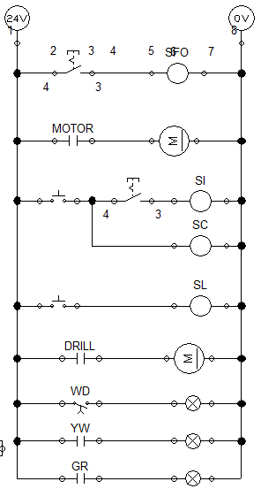

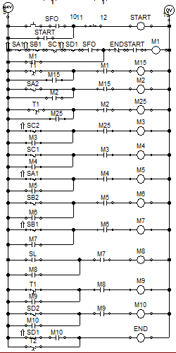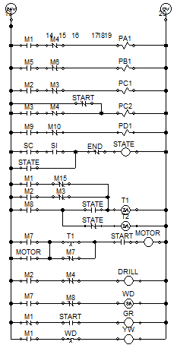

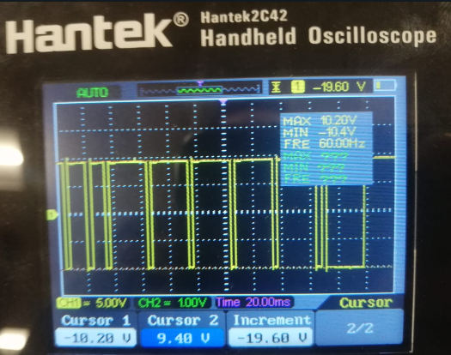Regarding the rs232 communication the first tests were implemented to deploy the RS232 BD module that was acquired, the first basic program was developed to send data through the module, at first was difficult because neither the customer and the organization were aware at all about the module, nevertheless the customer obtained the basic diagram to implement it and it was deployed successfully with a 20Vpp.

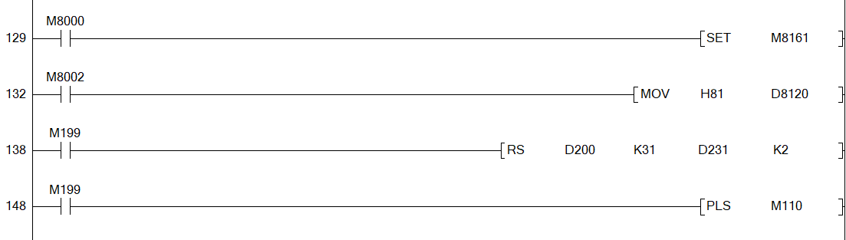

* Data rate: 9600 bauds
* Bits:8bits
* Parity: OFF

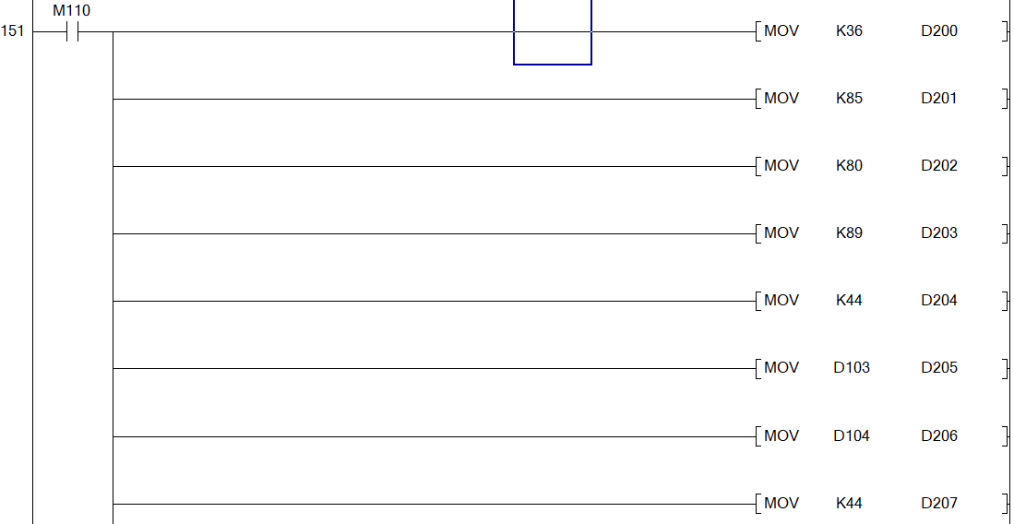

* STRING: $UPY,XX,XX,XX,XX,XX,XX,X,29$&
* ASCII: 36 85 80 89 44 X X 44 X X 44 X X 44 X X 44 X X 44 X X 44 X 44 50 57 36 38
* HEX: 245550592c00ff2c00ff2c00ff2c00ff2c00ff2c00ff2c312c32392426

